**Tourism Scrutiny Group Report February 2019**

**1. Purpose of Report**

For a long time, tourism has been considered as a low environmental impact industry with few externalities associated with it. More recently it has become accepted that tourism demand has significant economic impact at both the macro and micro level by modifying the demand and supply of certain goods and services. Some of these impacts and externalities are positive i.e. jobs, growth in business revenues but there are also some negative impacts – congestion, pollution, rising demand for public goods paid for by local residents for example.

In line with the separate Scoping Document, this report aims to provide an over-arching context and outline the following:

* Oxford’s offer and performance as a tourist destination
* Oxford City Council’s role in tourism management, and
* Other background information linked to the requirements of the Scoping Document.

The report is starting point for the collation of a wider base of evidence to support the findings of the scrutiny group.

**2. Oxford’s Tourism Offer**

We are fortunate to have a standout visitor offer in Oxford with the potential to appeal to a broad range of tastes. The city welcomes an estimated 8 million visitors each year, creating significant economic and cultural benefits, alongside associated demands and costs.

Oxford’s history and academic pedigree shapes its global brand. In addition to the Colleges and grounds of the University of Oxford and circa 1,500 listed buildings dating from the 11th century onwards, the city has numerous cultural attractions with a significant concentration of them in the city centre such as the Ashmolean Museum, Pitts Rivers, Museum of Natural History, Weston Library, Martyrs’ Memorial, Radcliffe Square and the Castle together with the Sheldonian Theatre, New Theatre and Playhouse.

Oxford is flat and compact, with many of its major attractions, such Oxford Castle, and its centrally located parks, rivers and gardens. A range of events are held throughout the year with a range of walking and also bus tours all year round. Oxford’s literary history and attractiveness as a filming location add to the diversity of the offer, as does Westgate, Oxford’s newest shopping and leisure experience, which can reach a new visitor demographic. Cinema, music, theatre, comedy and a range of dining options add further the diversity of the offer, with rooftop bars and dining. Oxford’s offer is beyond that of most cities its size.

Oxford is also easy to reach from London and Birmingham, as well as the major airports in the area. It is also an ideal point from which to explore other attractions such as Blenheim, Bicester Village and the Cotswolds.

**3. Oxford’s Performance as a Visitor Destination**

**3a. Economic Impact of Tourism 2014-17**

The economic impact of tourism to Oxford and Oxfordshire has continued to grow with the value of visitor expenditure now exceeding £2 billion per year for the very first time. We welcome over 27 million visitors a year to Oxfordshire (7.55M trips and £873m value in Oxford) and the sector supports nearly 35,000 jobs - one in every 10 jobs across the County.

Annual reports, commissioned by Experience Oxfordshire examine the volume and value of tourism and the gross positive impacts of visitor expenditure on the local economy. They provide comparative data against previously published data, with a one year lag. The results are derived using the Cambridge Economic Impact Model. The three key surveys used to measure volume and expenditure from tourism trips are the GB Tourism Survey (domestic overnight trips), the International Passenger Survey, and the GB Day Visitor Survey. Moreover, data from accommodation occupancy and visitors to visitor attractions is used to estimate year-on-year changes in the volume and value of tourism related visits. The accuracy of these sources varies and results should be regarded as estimates which are indicative of the scale and importance of visitor activity in the area. Sample sizes change year on year, so results are best viewed as a snapshot. The year on year comparisons below are thus provided with caution.

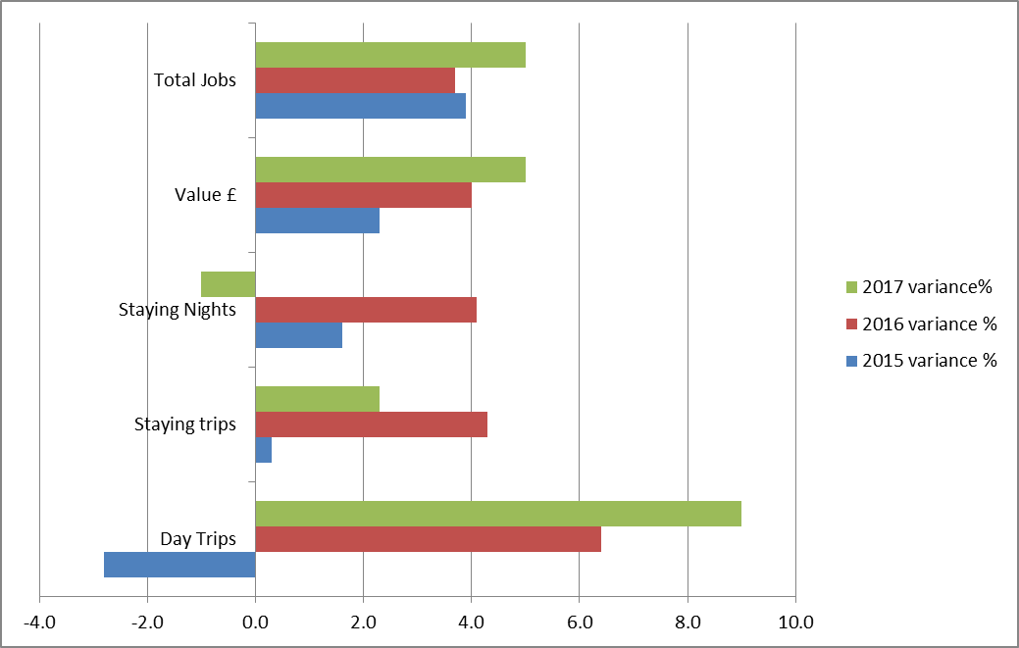

Figure 1: Year on year performance – Cambridge Model estimates

**3b. Visitor Perceptions**

Since April 2015, the national tourist boards of VisitEngland, VisitScotland and Visit Wales have been tracking visitor perceptions of destinations across GB in a continuous weekly tracking study. In 2018, VisitEngland commissioned the production of several destination summary reports, drawing on the findings from the continuous tracking data, for all destinations where sample sizes were sufficiently robust. The sample base for the study is GB holiday takers – those who have taken a GB break in the past 12 months or are expecting to in the next 12 months. These tracked loyalty, satisfaction and perceptions.

|  |  |  |  |
| --- | --- | --- | --- |
| Loyalty Ladder | Oxford average | City/Large towns average | GB destination average |
| Loyal | 13% | 18% | 17% |
| Considerers | 51% | 49% | 48% |
| Rejecters | 29% | 24% | 25% |
|  | | | |
| Satisfaction | 39% | 48% | 49% |
| Likelihood to revisit | 7.9 | 8.4 | 8.4 |

Fig2: Visit Britain Visitor Perceptions, 2018

Further information on Visitor perceptions of Oxford’s characteristics and aspects of its welcome can be found in Appendix 1.

**3d. City Centre Footfall**

Oxford City Council monitors footfall in the city centre on Cornmarket Street, Queen Street and George Street.

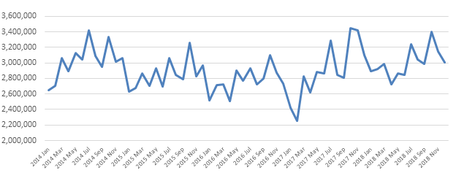

          Figure 4: Springboard Footfall measures in Oxford, 2014-2018

In the first half of 2018 eight per cent more people visited the city centre compared to the same period last year bucking national trends which have seen footfall dropping for the past year. Nationally the rate of decline in January is now slowing year on year and despite local footfall also dropping Oxford is still achieving the same levels of footfall it was 2 years ago.

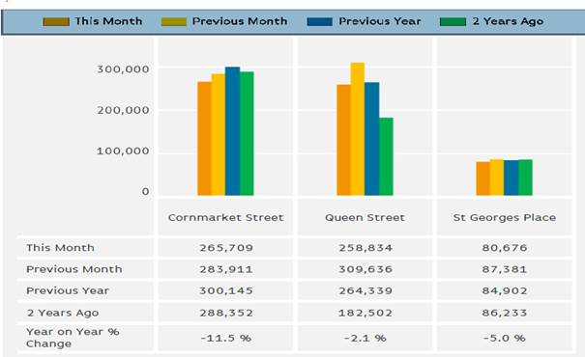

             Figure 5: Footfall measure by street January 2019.

The decline in recent footfall figures is likely to be reflective of the continuing change in shopping habits and the usual post-Christmas slump rather than a decrease in tourist numbers.

**3e. Hotels and Short Stay Accommodation**

As of 2017, Business rates data showed that there were 26 hotels and 46 guest houses in the city. In the previous 5 years the hotel supply had increased by 17.6% and the guest house supply had reduced by 6.9%.

Recent research undertaken by the City Council shows the following overall increase in hotel provision since the earlier study was carried out in March 2007. This assessment is based on the data collected and published as part of the Annual Monitoring Reports (AMRs) for the following eight years up to 2015. The table below shows published position, taken from the 2015/2016 AMR. 601 additional rooms have been given permission since, taking the estimated total, once completed, to over 3,200.

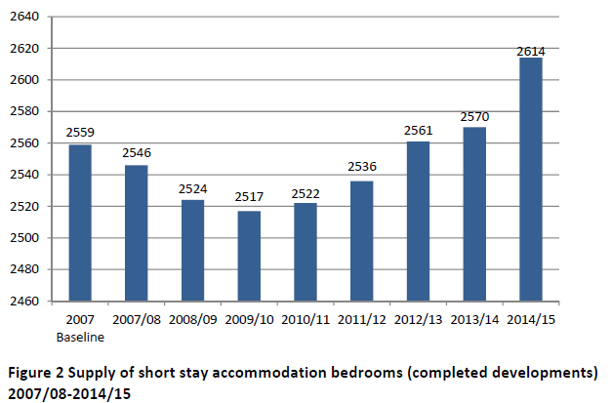

Figure 3: Hotel room data: Oxford City Council AMR

There has been considerable investment activity in the hotels sector in Oxford over the past 5-10 years. Below is a summary of large hotel planning permissions in the last two years:-

* 180 bed Easyhotel in Summertown
* 180 bed hotel at Cooper Callas site on Paradise Street
* 90 rooms at Greyfriars Court, Paradise Square
* 43 rooms at 15-19 George Street
* Holiday Inn, Peartree - erection of four-storey extension to hotel
* 71 bed Travelodge at Templar Square
* A range of other smaller extensions.

**4. Oxford City Council’s Current Role in Tourism Management**

**4a. City Centre Management**

As previously highlighted, with such a concentration of tourist attractions located in Oxford’s City Centre, tourism is a significant priority within city centre management and vice versa. In 2016, as part of strategic planning for the city centre a series of City Centre Visioning Workshops were held for key stakeholders. Four strategic themes and two Operational Themes were identified.

**Strategic Themes:**

* *Wellbeing*: to make the city centre look and feel attractive, clean, green, sustainable, safe and well regulated
* *Movement:* to ensure effective transport and pedestrian access to and within the city centre.
* *Experience:* to promote a diverse range of activities that meets the needs of a modern economy and contributes to Oxford as a world-class city. This is to include promoting first class customer service and visitor welcome across the city.
* *Appeal/Attraction:* to celebrate the history and diversity of Oxford and make the city feel more vibrant, alive with people and inclusive for all.

**Operational Themes:**

* *Management:* to facilitate debate on managing the interface of all stakeholders in the city centre and investigate the optimum way to manage the issues facing the centre.
* *Promotion:* to invest in world reaching promotion that Oxford is a great place to live, work, shop, visit, invest and enjoy.

All of these themes include a component that relates to tourists and the impact of tourism on the city centre such as improving the public realm. For example Oxford has a highly attractive historic environment of national significance but there are however opportunities to better realise its potential through environmental improvements to the public realm and creating a more legible way of connecting different parts of the centre together (see Appendix 2). The recent redevelopments of Frideswide Square, Westgate Shopping centre and the current redevelopment of Northgate House provide a catalyst to kick-start this approach, but this needs to be explored in detail through a review of the public realm, which the City Centre Manager is currently carrying out. This review will identify those streets and squares within the City centre that are failing to contribute to the intrinsic character of the area and suggest how this could be fully realised in association with partner organisations.

Alongside a public realm review, an update of the street-scene manual is required. The City and County Councils are committed to continually improving the appearance and function of the city centre’s streets and spaces and as such this document which sets out a palette of acceptable materials to be used now needs updating.

Many City Centre Stakeholders anecdotally report a desire for more pedestrianisation in the city centre to improve the environment, accessibility and ease pedestrian congestion which is often attributed on the millions of tourists visit the city. A city centre consultation will be held on the standards of the city centre environment to back up these anecdotal aspirations.

The stakeholder workshops also focused on the need for clearer signage and wayfinding across the city. Hidden gems such as the Covered Market and access to the river frontages are not signposted clearly. The route from the station to the centre is also cited as poorly signposted. This is an issue and clearly needs improving to create a better destination. The current wayfinding scheme was delivered in 2012 but due to major redevelopments in the city centre since then many signs need updating however there has been no budget allocated since 2012 to do this. The Oxford Explore wayfinding system used cutting edge technology when it was first introduced but the QR code system is now well established and the system could be more user-friendly.

**4b. Visitor Welcome Workshop 2015**

In early 2015, the OSP undertook some partnership work on Oxford’s Visitor Welcome mapping the visitor experience and studying satisfaction levels and asking;

1. **Functional** - Do we have what our visiting customers need?
2. **Accessible** - How easy is Oxfordshire to visit and explore?
3. **Emotional** - How do visitors feel when they are here?

It asked what needs to change? What actions are needed How do we deliver those?

Priorities were identified including

* People
* Place
* Tourism Services
* Travel & Transport
* Marketing and Information

An outline plan to improve the welcome was developed. Some elements of this have been implemented by partners since such as improvements by Oxford Bus Company with their Park & Ride Service, raising awareness of service levels among the taxi trade (public and private), and efforts to improve information provision. Yet, much of the work was not adequately resourced.

Reviewing this work, what went well and the lessons from it will be important in the scrutiny review process

**4c. Regeneration and Development Role**

The West End of Oxford is to undergo comprehensive redevelopment - expanding the city centre to the west - as a series of strategic developments take shape. Following the £440m Westgate development will be Oxpens. OXWED, as a joint venture between the Council and Nuffield College, owns the Oxpens site, which will be transformed into a new neighbourhood with a hotel, up to 500 new homes, together with around 12,000 m2 of offices and commercial space. Academic buildings, new homes, and commercial space will create a new cluster of working and living space, and importantly, new public spaces. The expansion of rail services at Oxford Station and proposed landmark station building with transport interchange has great potential to attract new tourists and dramatically improve the arrival experience for visitors. A hotel is proposed.

Osney Mead Industrial Estate is within walking distance of Oxford station, and fronts the Thames. This 18 Hectare site, regarded as an under-utilised industrial estate in need of modernisation is subject of emerging plans to transform the area into a new ‘innovation district’ that can harness the economic potential of Oxford’s diverse knowledge base in specialist digital and engineering activities. The site also offers the potential to create much needed new public spaces and enhance walking and cycling connectivity with the adjacent city centre.

**4d. Planning Role: Oxford Local Plan 2036**

The Local Plan seeks to encourage sustainable tourism through Policy V5. It seeks to manage the negative impacts of day visitors through the management of coaches and congestion of the arterial roads and public realm of the city centre; and encourage tourists to stay longer through new short-stay accommodation and tourist attractions in locations where they are easily accessible through sustainable travel (e.g. City and district centres or those with good access).

Planning permission will be granted for new tourist attractions where proposals are realistically and easily accessible by walking, cycling or public transport for the majority of people travelling to the site will not cause environmental or traffic impacts; and they are well related to any existing or proposed tourist and leisure related areas; and add to the cultural diversity of Oxford.

**4e. Funding and Investment attraction**

The City Council will seek to attract public and private investment for vital infrastructure or tourism product as part of its aims to create a successful and sustainable economy. Experience Oxfordshire has also been successful attracting funds from Government for Tourism promotion and from its tourism sector partners to promote the county-wide offer.

Oxford City Council is currently eligible to bid for a portion of the £675 million Future High Streets Fund which has been set up to help local areas respond to and adapt to the changes the High Street is facing. It will serve two purposes: it will support local areas to prepare long-term strategies for their high streets and town centres, including funding a new High Streets Taskforce to provide expertise and hands-on support to local areas. It will also then co-fund with local areas projects including investment in physical infrastructure, including improving public and other transport access, improving flow and circulation within a town / city centre, congestion-relieving infrastructure, other investment in physical infrastructure needed to support new types of use and heritage asset development. Council Officers are currently exploring the potential of this fund to contribute to the Council’s overall economic, city centre and sustainability aims.

Business Improvement District: The introduction of a Business Improvement District (BID) in Oxford City Centre remains an opportunity to finance the management of tourism. A BID is a business-led and business funded body formed to improve a defined commercial area. The potential benefits and uses of BIDs are wide-ranging and funded activity might include:

* Enhanced marketing and promotion
* Spend on infrastructure, movement and environment
* Place shaping activity
* Facilitated networking opportunities with neighbouring businesses
* Staff resource for management and ambassadorship.

A BID is funded through the BID levy, which is normally between 1% and 1.5% of the hereditament's rateable value. Once a ballot is successful the BID levy is mandatory for all eligible businesses above the threshold set in the BID proposal. BIDs can choose to exempt certain businesses from paying the levy (and therefore from voting in the BID ballot). Many BIDs exempt the smallest businesses; and some exempt certain business sectors.

CIL/S106: As city centres continue to transition into the future there will need to be more of an experiential offer, improved Streetscene and visitor management within the public realm. Public art is a particularly good way of achieving this and can be used strategically to change and influence the way visitors move around a city centre.

Tourism Levy: A number of places have started exploring the case for levying forms of tourism tax. Indeed tourism levies operate in a number of EU cities or towns. A number of councils in the UK, Birmingham, Brighton, Edinburgh, Cornwall and most recently Bath councils have all discussed the possibility of introducing a tourist tax but none have gone ahead yet.

Edinburgh councillors have voted in favour for what could be the UK’s first. The Transient Visitor Levy (TVL) scheme would include a flat £2 per night room charge, applicable to all types of accommodation apart from campsites. It will only come into effect once the Scottish Parliament passes enabling legislation, and would raise £14.6m each year. Birmingham is the most likely candidate to take this forward in England at present, but this will be within the context of them hosting the Commonwealth Games – the levy will be targeted, hypothecated and time limited (as was the Olympic tax in London).

The basic principle of a tourist tax is that it provides a means to generate additional funding for the tourism industry (e.g. museums and galleries) and/or funding for public services used by tourists.

There are several ways in which a tourist levy could be introduced. However, it is understood that the city would need to obtain central government approval (probably through primary or secondary legislation possibly through a Parliamentary Act). This would require the council to clearly articulate;

* How would a tourism levy be charged and at what rate?
* How would it be collected and administered?
* What exemptions would apply?
* How much revenue could be raised?
* How would it be spent and under what governance arrangements?

A local tourist tax is only likely to be acceptable if a local authority can demonstrate that:

* there is a robust evidence base that the local economy could support the introduction of the tax, including the likely start-up, collection and enforcement costs;
* existing alternatives, such as Business Improvement Districts, have been fully considered;
* there is local support for the tax (a referendum of some sort); and
* the scheme has been developed in partnership with local businesses and residents, who should continue to have a voice in the evolution and review of the scheme.

In considering a local levy, the council would have to make a very robust case or rationale for the levy including how it will effectively target this. It would also need to undertake the cost benefit analysis of administering it including mitigating the unintended consequences. As an alternative to the taxation of bed spaces in hotels, there may also be options for introducing a local road charge for high emitting coaches, for example, although this would be for the County Council to decide, and has yet to be explored.

**4f. Street-scene services; waste collection & deliveries:**Getting the everyday services right is imperative to the successful operation of the city centre and providing a clean and safe environments for its visitors. The City Council has set out ‘Street-scene and Ground Maintenance Service Standards’ which highlight that shopping areas of high footfall are swept daily as are the bins emptied daily. It sets out how businesses can report problems and there is an undertaking to provide extra cleaning within one working day of a report. Feedback on services is sought regularly by the City Centre Manager and the service standards are regularly reviewed.

Arranging for the collection of commercial waste is the responsibility of individual businesses. Regulations are in place on the timings of collections and when waste can be placed outside premises for collection in the main retail areas.  The County Council, as Highways Authority, regulates delivery timings across the city centre. In general deliveries are permitted outside the hours 10am to 6pm. Enforcement of these regulations will become even more essential post Westgate re-opening with greater traffic in the City

City Ambassadors are recruited by Oxford City Council to identify problems across the City and report back to Enforcement Officers if action is required. Two Ambassadors work 6 days a week, 6 hours a day.

**5. Destination management function and coordination**

VisitEngland’s 2014 Guidance Document on City Centre Management and the Visitor Economy states City or town centre management is often described as ‘a coordinated pro-active initiative designed to ensure that town and city centres are desirable and attractive places’. Town Centre Management, in particular in its most recent incarnation Business Improvement Districts (BIDs), often has a mandate for marketing the place. Destination management is a process of leading, influencing and coordinating the management of all the aspects of a destination that contribute to a visitor’s experience. Destination Management Organisations (DMOs) are involved in developing product, setting out what is needed in terms of physical improvement, service standards and facilities in order to meet the growing expectations of tourists and delivering initiatives to meet those expectations. Although the most visible output of destination management is often the marketing so there is a misconception that it is a marketing based activity. In many cases DMOs cover a much wider geography than a town or city centre. The reality is often not that clear cut and every local area has variations and as local priorities and funding levels change the work of destination management and city or town teams cross over. Regardless of local roles and responsibilities between delivery organisations the functions are interdependent and each type of organisation has expertise that should be shared and activity that should be aligned to enable each to maximise the growth potential for local areas.

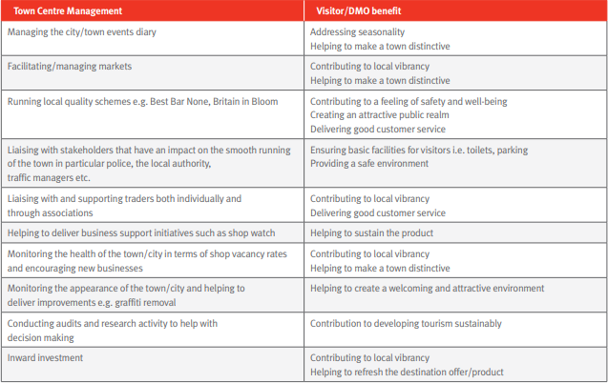

Figure 6: Guidance Document | City Centre Management and the Visitor Economy | VisitEngland |

**5a. Experience Oxfordshire, Board membership role**

Experience Oxfordshire (EO) is the official Destination Management Organisation (DMO) for Oxfordshire. Experience Oxfordshire is the trading arm of the parent charity, the Experience Oxfordshire Charitable Trust, and are a not-for-profit partnership organisation that is committed to the promotion, management and development of Oxfordshire as a great destination to live, work, visit and do business. EO work with businesses to grow and develop the visitor economy and work to ensure that Oxfordshire becomes a leading destination for tourism, culture and business.

They have a growing Partnership network of businesses spanning all parts of the visitor economy and through effective collaboration are working to ensure that Oxfordshire is a world renowned destination of choice.

While it is difficult to measure the direct impact of tourism promotion efforts, there is undoubtedly a positive impact. In 2017 the EO visitor guide was downloaded 18,000 times, they have 17,000 followers on twitter and the visitor information centre welcomed just fewer than 500,000 people. They have won awards for DMO and VIC of the year very recently. They play a vital role in supporting and promoting tourism. Their membership has grown well over the past three years and they have recently taken on a new business manager to further develop their membership offer.

EO is still in receipt of a funding contribution from the Council, but evolving their financial model. In 2011 Experience Oxfordshire were given a ten year lease for City Council owned premises on Broad Street. The rent was £85,000 per year and increased to £95,000 following a rent review in 2016. The Council paid the rent by awarding a second annual grant to Experience Oxfordshire. The total grant contribution budgeted for 2018/19 is £173,000, made up of the £95,000 rent reimbursement plus a £78,000 service grant. The four year service grant agreement expires in March 2021. The Council’s consultation budget proposes a reduction of 20k next year then 25k with the remainder in year three. The City Council will cease paying a grant to cover EO’s rent in 2021.

**5b. Pressures and Challenges**

While there are significant economic benefits of tourism, it can also make the city centre feel more like a crowded tourist destination than an asset for local residents and workers to enjoy. There is a perception that many Oxford residents living in the less affluent areas seldom go into the city centre as they do not feel it is for them, or that those that work here do not enjoy the centre in the evenings and weekend.

Such high numbers of visitors also place a strain on Council services, such as keeping the streets clean. Large groups of tourists create additional waste; require Public Toilets, Coach Parking, and adequate Wayfinding. The present wayfinding scheme may benefit from improvements so visitors can successfully navigate their way around the centre. As a result of the redevelopment of the Westgate Shopping Centre and other smaller redevelopments in the city centre some of the signs are now incorrect but there is no budget to replace or update them.

**6. Concluding officer remarks**

It is likely, based on previous discussions and evidence available, that the case for targeted and heightened level of coordination around visitor management needs to be explored properly.

Past experience in this area suggest that without a clear and realistic plan, leadership and resourcing, future destination management work will not be successful.

It is important to decide on what is possible, and the level of ambition we wish to show, and ensure resources are better coordinated alongside clear leadership. This is of course set against a backdrop of budgetary pressures for local government and reducing funds for tourism.

Despite significant visitor numbers and the tourism economic benefits, should further marketing opportunities be explored to assist with increasing tourist dwell time and encourage visitors to stay longer and to shop in Oxford?

**Appendix 1 – VisitBritain Perception Survey**

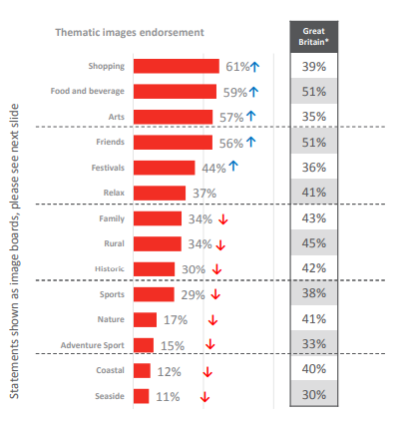

Themes and place, Visit Britain Visitor Perceptions Survey, 2018

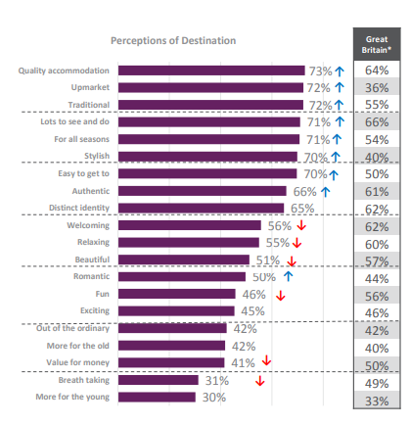

Perceptions and place, Visit Britain Visitor Perceptions, 2018

**Appendix 2**

***Distinctive areas of the City Centre***

City centres are defined by the historic phases of development and renewal that they undergo. In a historic city like Oxford, this has given rise to distinctive areas that have their own character, uses and opportunities. The character of these areas can also be harnessed further to help communicate their identity and improve the sense of orientation for those who use them, particularly those new to it such as tourists. The city centre has five areas of the city which have their own distinctive character and may require differing approaches to place shaping and public realm. The perceived boundaries of these areas do overlap to show how in practise they do directly relate to each other in a dynamic way.

**The High:** The High is the area of the city to the north and south of the High Street comprise a range of educational and cultural uses in historic buildings, which help to define the intrinsic character of the City centre. It includes a number of leading University of Oxford colleges and associated buildings, such as the Radcliffe Camera and the Bodleian Library which are truly iconic buildings that place Oxford on the world stage. This area comprises a number of listed buildings and lies within the heart of the City and University Conservation Area. These historic buildings, the spaces between them and the medieval street patterns create an attractive and interesting public realm providing a memorable experience for tourists and those visiting or passing through this area.

*Aims and opportunities for The High:* The principle aim will be to support proposals and investment in the historic fabric of this area, which will positively improve and enhance its historic legacy. This approach will help to support key educational and cultural uses and strengthen Oxford’s role as a world-class tourist destination. Proposals to improve walking and cycling routes within this area and their linkages to the City centre will be supported. The High Street is a broad thoroughfare, and currently heavily used by buses and taxis; through the evolution of the Oxford Transport Strategy, there may be opportunities for part pedestrianisation.

**The Commercial Centre:** This area includes thePrimary Shopping Area (PSA) as defined within the Local Plan which comprises the main commercial uses within the city centre. Carfax Tower is considered to be the heart of the city. The primary shopping streets are Cornmarket Street, Queen Street and the eastern end of George Street and the western end of High Street. The shopping experience is enriched by two shopping centres the Clarendon centre and the new Westgate Shopping centre open in late 2017 after extensive redevelopment. The ‘Covered Market’ provides a distinctive retail offer together with weekly markets in Gloucester Green. Next to Gloucester Green is the bus terminal for services to London and local services to neighbouring towns. To the south-west is the Castle site which is a successful example of regeneration that includes the Malmaisson hotel and the historic Castle Mound. This area comprises a number of listed buildings and lies within the City and University Conservation Area.

*Aims and opportunities*: The redevelopment of the Westgate Shopping centre will hugely strengthen the retail and leisure experience for those visiting, working and living within this area. This may also shift the axis of the commercial centre slightly to the west of the city but will create opportunities for a greater mix of retail, leisure, service, office, cultural and tourist uses within this commercial centre. Significant improvements to the public realm will be delivered by the Westgate development with the formation of new public squares, it will be important to ensure that these measures are directly linked with the rest of the City centre as part of a programme of way-finding and wider public realm improvements. In line with this is the pedestrianisation of Queen Street and the 18 month trial now starting to remove buses entirely from this street. With regards to Cornmarket, proposals to improve the public realm and street furniture need to be taken forward. There is also the opportunity to create new street trader stalls and create its very own sense of space. Specific mention also needs to be made concerning George Street, it has become a food/leisure and evening destination in recent years and there is the possibility for part-pedestrianisation and improvements to the streetscape.

The future redevelopment of Oxpens and the Station site offer significant opportunities to improve the connectivity and public realm that could bring real benefits to the City centre.

**St. Giles:** Thisarea comprises the land and uses around St. Giles, the main northern and perhaps most attractive entrance into the City centre. It runs from St. Giles church in the north down to Broad Street in the south. The area is characterised by University of Oxford colleges, including both St. Johns and Balliol. St. Giles itself is a wide attractive tree lined street, with college buildings of significant historic and architectural interest making an important contribution to the public realm. The Ashmolean, a Museum of national importance is located on the corner of St. Giles and Beaumont Street, directly opposite the Randolph Hotel. The main commercial uses are largely focused on the west side of St. Giles. Broad Street to the south includes an important presence from the University of Oxford including Balliol and Trinity Colleges. Towards the end of the street wider cultural uses flowing from the University offer some diversity, which includes the Sheldonian Theatre and Weston Library. The south side of the street comprises a good mix of retail and service commercial uses.

*Aims and opportunities*: The principle aim will be to support proposals and investment in the historic fabric of this area, which will positively improve and enhance its historic legacy. This approach will help to support key educational and cultural uses and strengthen Oxford’s role as a world-class tourist destination. Proposals to improve walking and cycling routes within this area and their linkages to the City centre will be supported. The future use of Broad Street and St. Giles should be explored through the Oxford Transport Strategy (OTS) together with emerging Local Plan policies to maximise the benefits for those walking and cycling in the area. Detailed proposals have come forward for the partial pedestrianisation of Broad Street towards the eastern end of the street, which would bring real improvements to the public realm. These measures will add to the opportunities for a greater mix of uses and activities and promote the vitality and viability of this area.

**The Station Site and Oxpens:** This area of the city lies to the west and is bounded by the railway line it comprises some key land uses such as the Railway Station to the north and the Ice Rink and surrounding open space to the south. It includes a number of major sites which are either vacant and or under-used. The walking and cycling routes to the City centre are well used but are not always clearly signed, providing a poor experience for those passing through the area or experiencing it as a visitor. In the midst of this area is **The ‘Island site’:** this site is bounded by Park End Street and Hythe Bridge Street and provides an important key link between the train station and the city centre. The ‘Island site’ together with the buildings on the south-side of Frideswide Square have recently been bought on a long-term lease by Nuffield College. The College is currently at the early stages of drafting a Master Plan for the future development of this site,

*Aims and opportunities:* This area of the city offers the most significant sites with development potential, such as the Station site, Oxpens and the Island site. Their future redevelopment, flowing on from the soon to be completed Westgate development, will be vital to the wider regeneration of the West End of the City centre. These sites have a high profile and their development particularly the Station site with a new train station and bus interchange has the potential to transform this area of the city. The new developments will comprise mixed-use schemes for residential, offices, R&D, retail and leisure uses that will provide the opportunity to help define the character of this area and create new public spaces. Walking and cycling routes between this area and others within the city centre could benefit from improvements both in terms of their condition, legibility and make better connectivity between key sites. Just outside the Western boundary, separated by the rail-way line and the river Thames, is **Osney Mead Industrial Estate**. If the University’s emerging masterplan is realised for this under-sued industrial site, and if the connectivity issues are managed, it is conceivable a new western innovation district, perceived as part of city centre, could be created in the longer-term.

**Follybridge and Riverside:** The Follybridge is located to the south of the City centre, which acts as a gateway to the city linking St. Aldates to Abingdon Road. The area around St. Aldates comprises a mix of uses including educational, commercial shops and offices and administrative buildings such as Crown Court, Magistrates Court. Adjacent to Follybridge there are some tourist / visitor related uses including a boat-hire business, pub and restaurant.

*Aims and opportunities:* This area around Follybridge has the potential for making better use of its tourism and service offer. It is situated next to the River Thames which does offer opportunities for adding to the transport connections around the city. The proposal is to develop a ‘riverside strategy’, which would extend out beyond city centre and seek to encourage more visitors walk or cycle in, or simply enjoy these areas. A riverside cycle improvement scheme is already being explored by the City and County Councils with a view to providing more direct and quicker routes around the city.